Claveria, Jorlyn Shane M.
Reyes, Maria Theresa N.
Segotier, Joy Melisa S.
BS INFO 3C – NAS 4_Lab 4

Deliverables
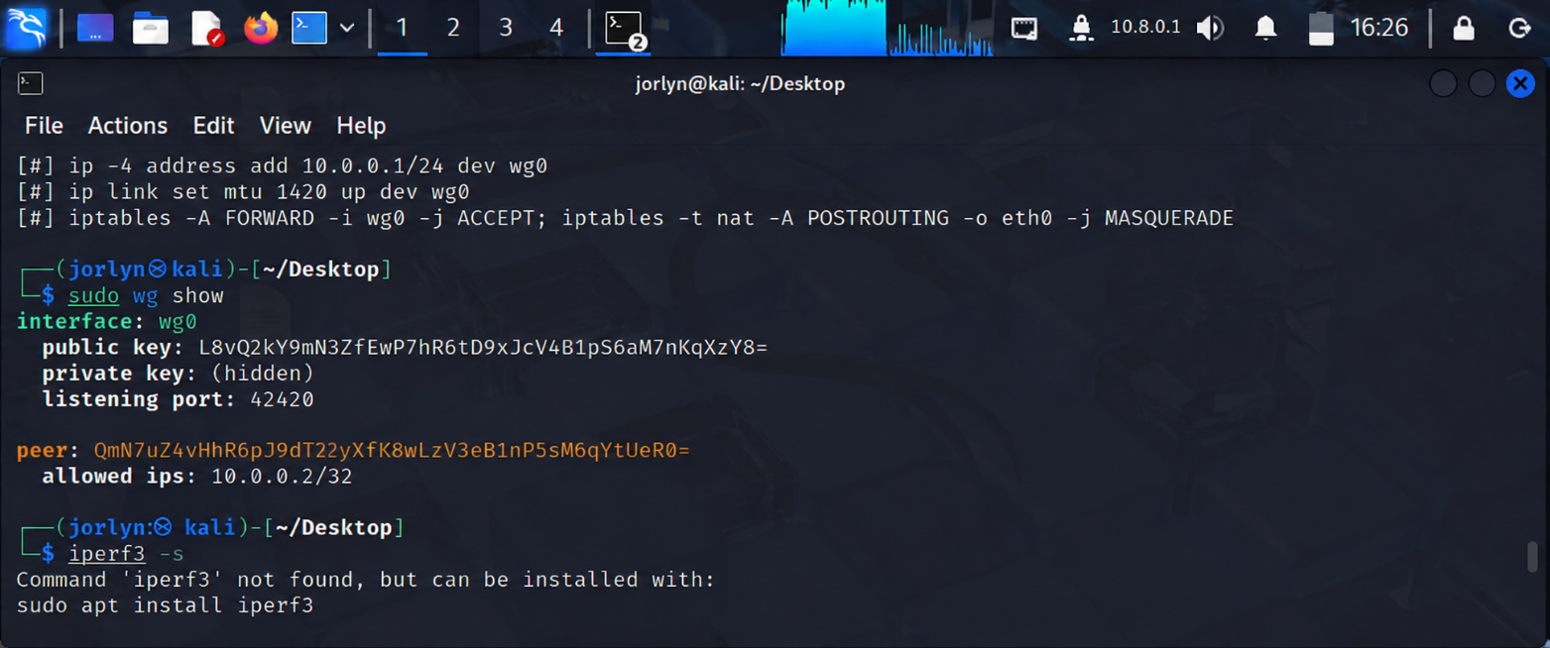

Critical Thinking & Security Analysis
1. Attack Surface: Compare the lines of code between OpenVPN and WireGuard. Why does a smaller codebase correlate with better security?
WireGuard has a much smaller codebase than OpenVPN, making it easier to review, maintain, and detect security vulnerabilities. Fewer lines of code reduce the chance of bugs and security flaws.
2. Stealth Mode: WireGuard does not respond to packets unless they are correctly encrypted with a known public key. How does this protect the gateway from "port scanning"?
WireGuard ignores packets that are not encrypted with a trusted public key. Because it does not respond to unauthorized requests, attackers cannot easily detect that the VPN service is running through port scanning.
3. Roaming: Why does a WireGuard connection stay "alive" when a someone moves their laptop from a home network to a coffee shop, while OpenVPN often requires a reconnect?
WireGuard automatically updates the client's IP address when the network changes. This allows the VPN connection to continue without reconnecting, unlike OpenVPN, which often requires a new connection.
4. Explanation of how "Cryptokey Routing" replaces the need for a Certificate Authority.
Cryptokey Routing uses public and private key pairs to identify and authenticate devices directly. Each peer trusts the other's public key, so there is no need for a Certificate Authority (CA) to issue and manage certificates, making the VPN setup simpler and more efficient.

